Dynamic memory allocation for primitive data types:

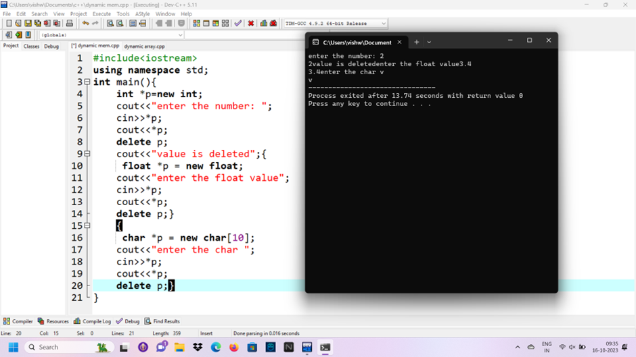

Dynamic memory allocation for array:

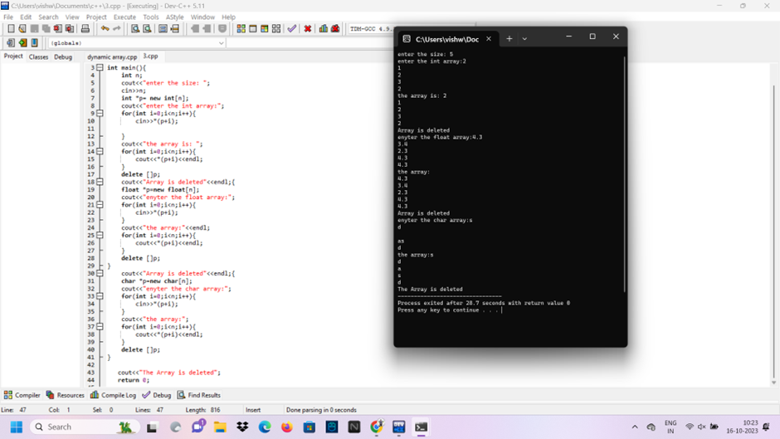

Dynamic memory allocation for object:

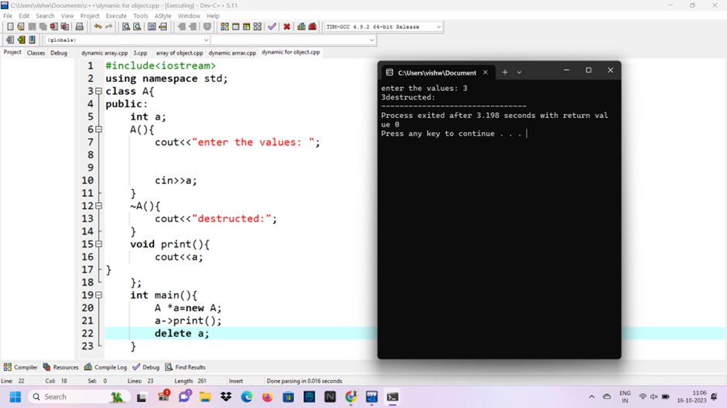

ARRAY AN OBJECT

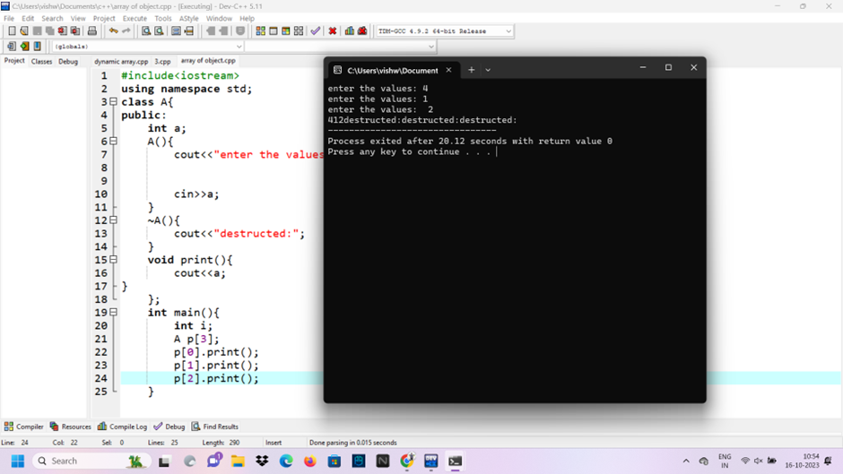

Dynamic memory allocation for object of an array:

